Washington Play and Learn Program
Washington Parks & Recreation
PO Box 383 Washington Depot, CT 06794
WPAL@washingtonct.org

2020-2021 School Year

AFTERCARE SCHEDULE AND ROUTINE
Program Dates and Times: WPAL runs Monday through Friday 3:15 to 6:00pm following the school calendar. On scheduled ½ days WPAL runs 12:45 to 6:00pm.
Our daily routine will be as follows:
3:15pm-3:30pm: Daily Attendance, Daily Meeting and Monitored 30 second hand washing
3:30pm-6:00pm: Snack, Homework/Reading Time, Play outside (weather permitting) or indoor, hands on activities. Pick up no later than 6:00pm is required.
Daily Attendance: Please send an email to wpal@washingtonct.org as soon as possible if your child will not be attending. In the case of an emergency you can call 860-868-2016 between the hours of 3:00pm and 6:00pm. Drop off care is available with 24 hours’ notice and approval from Director. All students must be registered with the welcome packet completed and submitted before attending after care.
Tuition: Tuition is due on a weekly basis (unless otherwise agreed upon); please pay on the last day your child attends of each week. Tuition is based on the days your child is registered, if your child is absent on a day they are scheduled to attend you are still responsible for tuition for the day. Please make checks payable to the Town of Washington with WPAL written in the memo.
Daily (3:15-6:00):$12 per child Extended days (12:45-6:00): $20 per child Drop in: $25 per child
Dismissal: Students are expected to be picked up no later than 6:00pm. You can pick your children up at the back door to the cafeteria. You will need to walk around the back of the school near the playgrounds. An alternate pick up form must be completed for another adult to pick a child up from the program; a valid picture ID will be required. Pick up after 6:00pm will result in a late pick up fee of $10 per child per every 5 minutes.
Please complete the forms in the Welcome Packet and email them back to wpal@washingtonct.org. Tuition for the first week is due the first day your child attends the program. I am looking forward to working with you and your children this school year! Please contact me via the email above with any questions, concerns, or suggestions.

Ken Schultz
Program Director

Policy Agreement-AFTERCARE
2020-2021 School Year

Child’s Name: _______________________________________ Date of Birth: ____________

- Registration Fee: A non-refundable fee of $25per child or $40 or family is due upon registration.

- Security deposit: A $75 deposit (for 1st child) and $25 per each additional child is due upon registration.

- Tuition: Tuition is due weekly. Tuition is based upon enrollment in the program and not on attendance. Checks should be made payable to The Town of Washington. Tuition is $12 daily per child, $20 per child on scheduled early dismissal days and $25 per child for drop ins.

- Returned check: A $25.00 fee will be assessed to your account for any check returned for non-sufficient funds.

- Program hours: The WPAL Program will run Monday through Friday 3:15pm- 6:00pm following the school calendar. On scheduled half days the program runs 12:45pm-6:00pm. In the event of inclement weather the program will be canceled if there is no school and/or an emergency dismissal.

- Late Pick Up: The program ends promptly at 6:00 PM. Repeated late pick up may result in the termination of childcare. There will be a late pick up fee of $10 per child for every 5 minutes a child is picked up late. Please pick your child up at the playground or cafeteria, you will not be able to walk through the school as it is closed after hours.

7. Withdrawal: A two week written notice prior to withdrawal is required or the security deposit is forfeited. Otherwise the security deposit is applied toward the last two weeks of care.

I / We understand and agree to adhere to all the policies stated above.
Parent/ Guardian: ________________________________________Date: __________________
Parent/ Guardian: ________________________________________Date: __________________

Alternate Pick Up Authorization
2020-2021 School Year AFTERCARE

I ___________________________ authorize my child, __________________________ to be picked up by the following adults listed below:

_________________________________________________________________________________________
Name Address Phone Number

_________________________________________________________________________________________
Name Address Phone Number

________________________________________________________________________________________
Name Address Phone Number

I understand that only the adults listed on this form will be allowed to pick up my child. A photo ID will be required in order for my child to leave with these adults, without a proper photo ID my child will not be allowed to leave the program.
*Please choose people within a 20 minute driving distance from the school. It is important that emergency contacts are able to pick up your child in a timely manner in the event of illness or an emergency.
Parent/Guardian Name Printed: ____________________________________________
Signature: __________________________________________ Date: _____________

Health Form Authorization
2020-2021 School Year

Name of Child: _________________________________________ Date of Birth: _______________

Mother’s Name____________________________________________________________________
Address _________________________________________________________________________
Home Phone Number _______________________ Work Phone Number______________________
Cell Phone _________________ E-mail Address: _____________________________________
Father’s Name____________________________________________________________________
Address__________________________________________________________________________
Home Phone Number _______________________ Work Phone Number______________________
Cell Phone _________________ E-mail Address: _____________________________________
Emergency Contact Name ________________________________________________________
Address__________________________________________________________________________
Home Phone Number _______________________ Work Phone Number______________________
Cell Phone _________________ E-mail Address: _____________________________________
Physician’s Name_________________________________________________________________
Address _________________________________________________________________________
Phone Number ____________________________________________________________________
Insurance Information _____________________________________________________________
Chronic Illnesses _________________________________________________________________________
Allergies ________________________________________________________________________________
Current Medications _______________________________________________________________________
________________________________________________________________________________
Special Information: ________________________________________________________________________________ ________________________________________________________________________________

Sunscreen Form
2020-2021 School Year

As the weather gets warmer, the children will be spending more time outside. You may wish to provide us with sunscreen for protection while your child enjoys outdoor play. If you would like for us to apply sunscreen to your child, please provide us with an unexpired bottle of sunscreen, labeled with your child’s first and last name. As with any topical medication or cream, the first application of any brand of sunscreen should be applied at home in order to evaluate your child’s possible allergic reaction to that product.

Name of Child: _________________________________________ Date of Birth: _______________

Parent/Guardian Name Printed: ____________________________________________
Signature: __________________________________________ Date: _____________

Getting to Know You
2020-2021 School Year

- What is your preferred name?
______________________________________________________________________________
- What grade are you in?
______________________________________________________________________________
- What physical activities or sports are you interested in?
______________________________________________________________________________
- What school subjects do you like?
______________________________________________________________________________
- What is something you do not like to do?
______________________________________________________________________________
- Are you afraid of something?
______________________________________________________________________________
For parents: what would you like to see your child doing after school?
__________________________________________________________________________________________________________________________________________________________________________________________________________________________________________
Tell us about your family, you can write something or draw a picture.

About WPAL Staff
Program Director of WPAL-Ken Schultz
Hello, my name is Ken Schultz and I was born, raised and lived in Litchfield county my entire life. We are a WPS/Region 12 Family. In addition to being the Director of the WPAL Program I am a Special Education Paraprofessional at Shepaug Valley High School. My wife Serina, has been a Special Education teacher for The Burnham School in Bridgewater and Region 12 Schools for the last 10 years. We also have a 12 year old daughter Sheyenne entering 7th grade at Shepaug Valley School and our 5 year old son Wesley entering into Mrs. Wescott’s Kindergarten Class (Class of 2033) OH MY. We believe it takes a village to give our children enriched experience in life. I am happy to be part of that village.
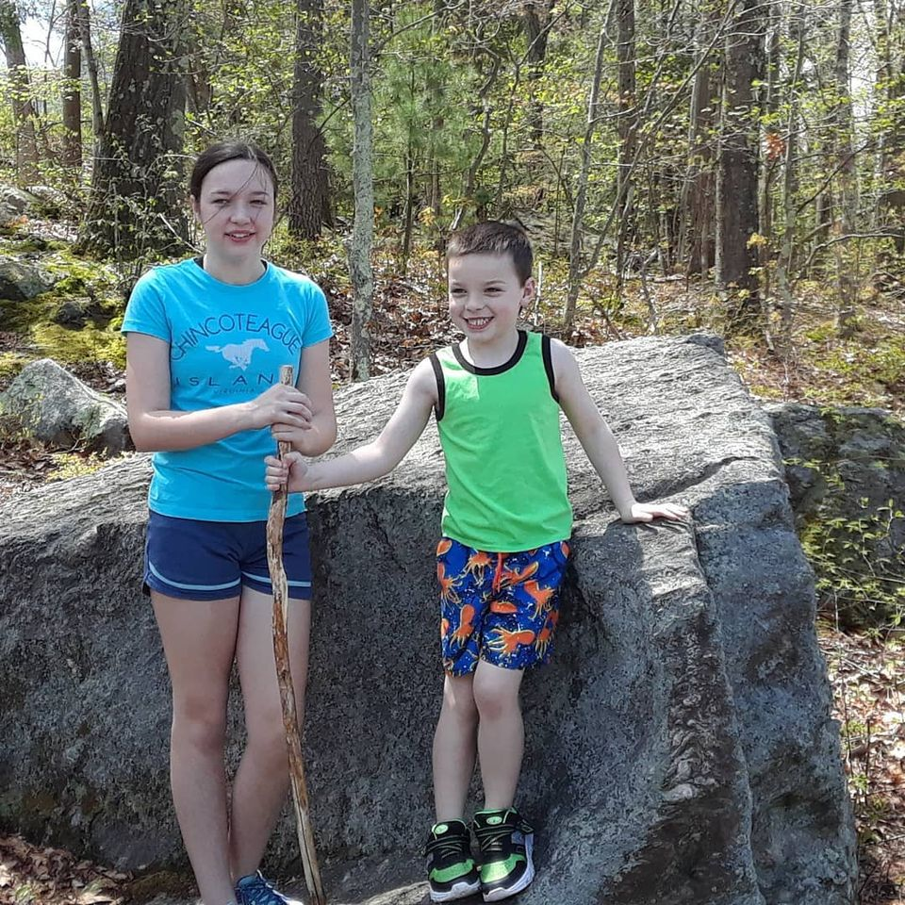
Assistant Program Director of WPAL-Shawnna Godshalk
My name is Shawnna Godshalk, family and I have been in Washington for many decades. My husband has a local carpentry company and I am a job coach at Shepaug valley partnership as well as a paraprofessional at Washington primary school. Our son Jackson attends school at WPS and he is in the 5th grade. I enjoy cooking and reading in my spare time.

WASHINGTON PARKS AND RECREATION
P.O. Box 383, Washington Depot, CT 06794, 860-868-1519
wpal@washingtonct.org
Washington Play and Learn Program-Aftercare

2020-2021 PROGRAM REGISTRATION FORM
Registration forms must be submitted by mail or in person to the Washington Town Hall Selectman’s Office.
FAMILY ACCOUNT INFORMATION
HEAD OF HOUSEHOLD NAME: _________________________________________ email:_____________________________________
MAILING ADDRESS:___________________________________________ TOWN:________________________ ZIP:__________________
PHONE: HOME:_____________________________ WORK: _____________________________ CELL: ____________________________
NOTIFY IN CASE OF EMERGENCY:
NAME: ______________________________________ RELATIONSHIP: __________________________ PHONE:____________________

Participant’s Name | DOB | Activity Name | Start Date | Time | Fee
 |  | WPS Play and Learn  Program | September 14th 2020 | Full Day: 3:15-6:00  ½ Day: 12:45-6:00 | Daily: $12 per session  Extended Day: $20 per session  Drop In: $25 per session

Please indicate needed days. Select all that apply. M______ T______ W______ Th______ F______

LIABILITY WAIVER
Participant will hold harmless the Town of Washington, the Parks and Recreation Commission, Region 12 and any officials, agents, instructors, directors and employees for any and all injury or damage which participant personally incurs or injury or damage to the person or property of others which participant causes or contributes to while participating in this program. I also understand that in the event of an injury our own personal medical insurance will be used. Unless indicated hereafter, the Washington Parks & Recreation Commission may use photographs including the above-named participant for promotional purposes and may use our email for program purposes. NO ____
Parent/guardian signature:_______________________________________________________ Date:_______________________________________

REFUND/CANCELLATION POLICY: A minimum number of participants is required to hold sessions. When registration is below the minimum, the Washington Parks and Recreation reserves the right to cancel the program with participants receiving full refund or credit. It is highly recommended that you pre-register as early as possible to avoid programs being cancelled due to lack of enrollment. Refunds are not available once a program begins.

